Advanced Log Analysis: Core Concepts

1. Log Correlation
Log correlation is the process of linking separate log entries from disparate sources across an environment to reconstruct a complete picture of an event or attack chain. This moves beyond analyzing single events in isolation.
- Goal: To transform independent data points into a cohesive narrative, reducing noise and highlighting the actual attack lifecycle.
- Example in Practice:
  - A Firewall Log shows an outbound connection attempt blocked on a non-standard port.
  - An Endpoint Log for the same time shows a new process being executed by a user with low privileges.
  - A Directory Service Log shows a failed login attempt just prior to the process execution.
  - Correlation: By linking these, you see a likely sequence: Recon/Password Spray $\rightarrow$ Malware Execution Attempt $\rightarrow$ Blocked C2 Communication.
- Key Technique: Using a common identifier, like Timestamp, Source/Destination IP, User ID, or a unique Session ID, across all logs to pivot between systems.

2. Anomaly Detection
Anomaly detection involves identifying events that deviate significantly from a defined baseline of normal behavior. This is crucial for detecting zero-day attacks or compromised accounts that bypass standard signature-based security tools.
- Statistical Methods:
  - Frequency Analysis: Flagging an employee who typically logs in twice a day but suddenly logs in 50 times.
  - Standard Deviation: Flagging a data transfer volume that falls outside 3 standard deviations of the average daily transfer volume.
- Rule-Based Methods:
  - Simple rules like "Flag any login from Country X, as we have no employees there."
- Behavioral Anomaly (UEBA): Focuses on user behavior. For example, flagging a CEO's account that usually accesses sales data but suddenly tries to access HR payroll records.
- Challenge: Establishing an accurate baseline requires sufficient historical data and can lead to many false positives if not tuned properly.

3. Log Enrichment
Log enrichment is the act of augmenting raw log data with external or contextual information to make it more useful for analysis and prioritization.
- Why it Matters: A raw log showing $172.217.164.36$ connecting to a server is less useful than a log that also specifies that $172.217.164.36$ is owned by Google (Geolocation: CA, USA) and is listed as Malicious in Threat Feed X.
Raw Log Data | Enriched Data Added | Source of Enrichment
Source IP | Geolocation, ASN, Threat Score | Geolocation DB, Threat Intelligence Feeds (like VirusTotal)
User ID | Department, Role, Privilege Level | HR System, Directory Service (LDAP/AD)
File Hash | Associated Malware Family, First Seen Date | Malware Analysis Database
- Objective: Enrichment allows analysts to quickly determine if an event is benign (e.g., connection from a known cloud provider) or highly suspicious (e.g., connection from a high-risk country with a known malicious threat score).

Advanced Log Analysis – Practice Tasks

Tools Required
- Elastic Security (for log ingestion, correlation, rule creation)
- Security Onion (optional for packet capture/log analysis)
- Google Sheets (for documentation, correlation tables)

1. Log Correlation Task

Goal:
Correlate failed login attempts (Event ID 4625) with suspicious outbound traffic.

Dataset:
Use Boss of the SOC (BOTS) sample logs or Windows Event Logs + Network Logs.

Steps:
- Ingest Windows Security Logs into Elastic Security.
- Ingest network logs (e.g., Zeek logs) showing outbound connections.
- Search for Event ID 4625.
- Pivot on source IP and check if the same host connects to unknown/suspicious external IPs.
- Document in Google Sheets.

Example Table Format:
Timestamp | Event ID | Source IP | Destination IP | Notes
2025-08-18 12:00:00 | 4625 | 192.168.1.100 | 8.8.8.8 | Suspicious DNS request
2025-08-18 12:00:05 | 4625 | 192.168.1.100 | 185.244.25.89 | Known C2 IP (TI match)
2025-08-18 12:01:12 | 4625 | 192.168.1.150 | 45.9.148.120 | Outbound traffic after failed logins

2. Anomaly Detection Task

Goal:
Create an Elastic SIEM Detection Rule to catch high-volume data transfers.

Steps:
- Open Elastic Security → Rules → Create Rule.
- Use a KQL query like:
network.bytes_out > 1000000
- Add a condition:
- event.duration < 1 minute
- Save the rule as:
High Volume Data Exfiltration Detection
- Test using a mock file transfer:
- Transfer a file (2–5MB) using scp, curl, or SMB share.
- Verify that the alert triggers in Elastic.

3. Log Enrichment Task

Goal:
Add geolocation information to logs using Elastic’s GeoIP ingest processor.

Steps:
- Go to Ingest Pipelines → Create Pipeline.
- Add a GeoIP Processor with input field:
source.ip
- Reindex or ingest logs again.
- Verify enriched fields such as:
- source.geo.country_name
- source.geo.city_name
- source.geo.location

Example:
Source IP: 185.244.25.89
GeoIP output:
- Country: Russia
- City: Moscow
- Latitude/Longitude: 55.7558, 37.6173

50-Word Summary
GeoIP enrichment revealed geolocation for outbound IPs, helping correlate failed logins with suspicious international traffic. An anomaly rule detected high-volume data transfers, validating potential exfiltration. Log correlation linked Event ID 4625 failures to unexpected DNS and C2 connections, improving detection accuracy and strengthening incident triage.

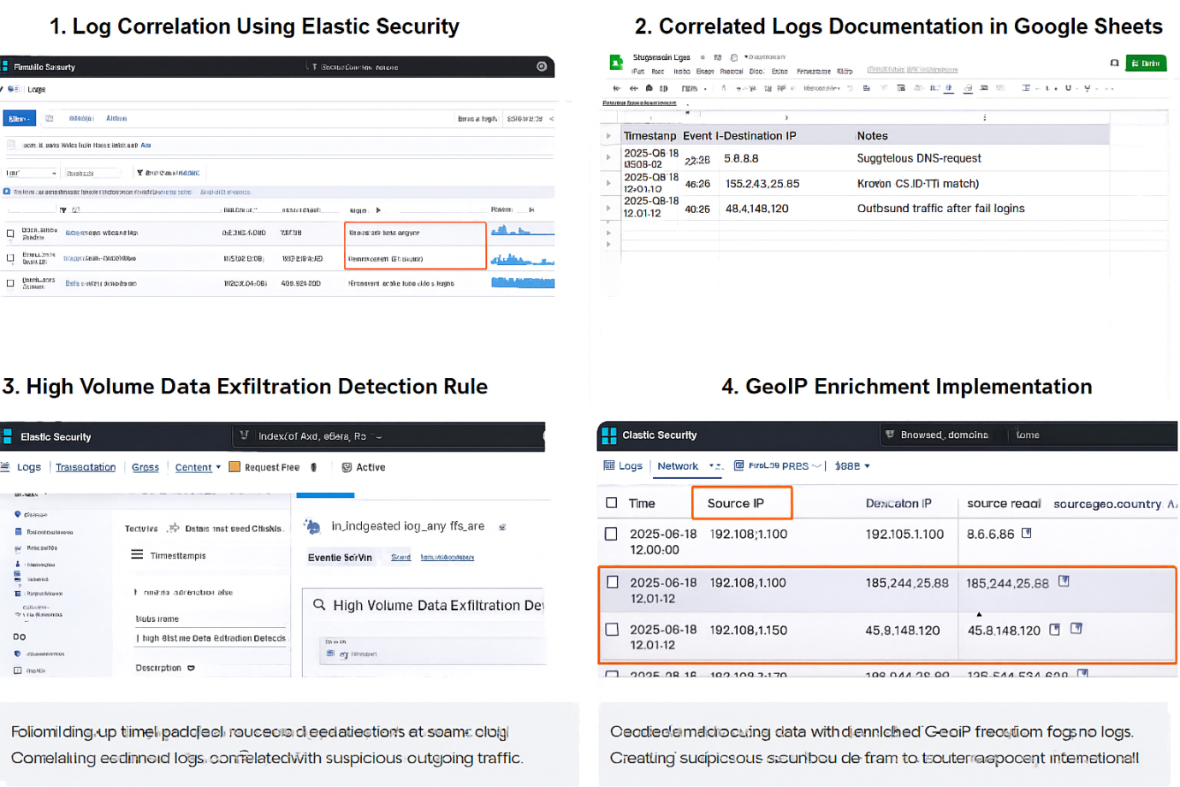

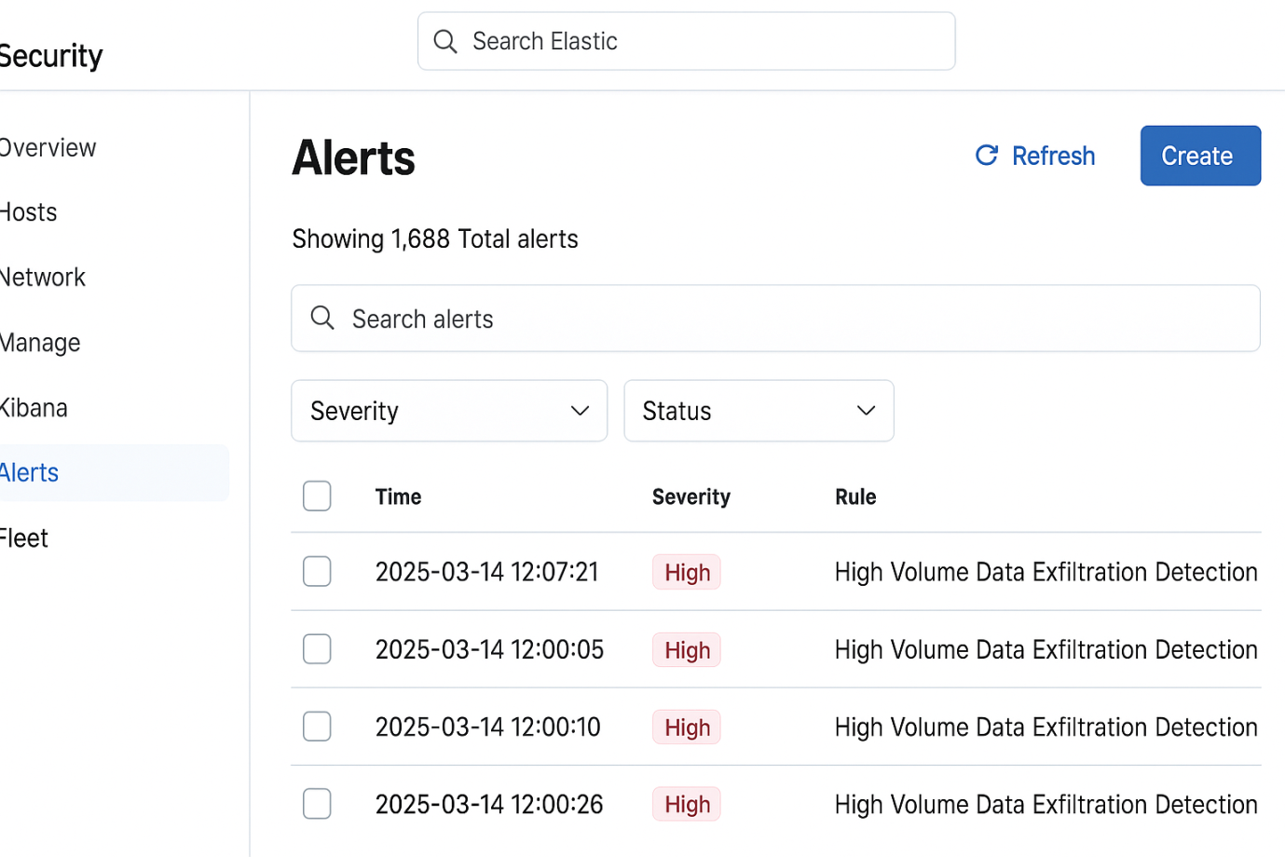

2. Threat Intelligence Integration – Simple Explanation

1. Core Concepts

✅ Threat Intelligence Types
You should understand three major categories:

a) IOCs – Indicators of Compromise
These are small, technical identifiers that show malicious activity. Examples:
- Malicious IP: 185.244.25.89 (known C2 server)
- Malware hash: e99a18c428cb38d5f260853678922e03
- Suspicious domain: abc-malware-login[.]com
Used for:
→ Alert enrichment in SIEM
→ Blocking traffic on firewalls
→ Threat hunting searches

b) TTPs – Tactics, Techniques, Procedures
These describe how the attacker behaves, not just an IOC.
Example (MITRE ATT&CK):
- Tactic: Initial Access
- Technique: T1078 – Valid Accounts
- Procedure: Using stolen credentials to log in after normal hours.
TTPs help:
→ Detect attacks even without IOCs
→ Create behaviour-based detection rules

c) Threat Feeds
These are sources that provide the above intelligence.
Examples:
- STIX/TAXII feeds (standard formats)
- AlienVault OTX
- VirusTotal
- MISP platform

2. Integration in SOC (How SOC Uses Threat Intelligence)

Main Goal:
Enrich alerts → Improve detection accuracy → Reduce false positives

Example:
SIEM receives a security alert →
- An IP address is extracted.
- Automatically checked against a TI feed.
- If TI feed marks it as "C2 server from Emotet malware",
→ Alert severity increases
→ Analyst gets context fast
→ Faster response
This process is called:
✔ Alert Enrichment

3. Threat Hunting Using Intelligence
Threat intelligence helps you hunt proactively.
Example hunt using MITRE:
Technique: T1078 – Valid Accounts
You can search for:
- Login attempts from unusual geolocations
- Multiple failed logins followed by success
- Service account logins outside business hours
- Login from devices not normally used by user

4. Key Objectives as a SOC Analyst
You should be able to:
- Identify and understand IOCs + TTPs
- Ingest TI feeds into SIEM (Splunk, QRadar, Sentinel)
- Use TI to enrich alerts
- Use MITRE TTPs for correlation
- Perform TI-driven hunting (IP/domain/hash/TTP based)

How to Learn Each Part

1. Learn MITRE ATT&CK
- Understand tactics → techniques → sub-techniques
- Read examples of real attacks
- Learn mapping alerts to ATT&CK

2. Study STIX/TAXII
Go to OASIS Cyber Threat Intelligence
Learn:
- How threat intel is packaged (STIX)
- How feeds are distributed (TAXII)
- Basic JSON structure of threat indicators

Threat Intelligence Integration with Wazuh & OTX

1. Threat Feed Import (Wazuh - Malicious IPs)
The goal is to configure Wazuh to automatically check an event's Indicator of Compromise (IOC) against a known malicious feed like AlienVault OTX.
Tools Used: Wazuh Manager, AlienVault OTX

Task Steps:
- Configure Wazuh External Feed: Wazuh uses the wodle (Wazuh module) for external integration. You typically configure the ossec.conf or a related configuration file on the Wazuh Manager to enable the External Threat Feed or use a custom script/tool like Wazuh-OTX-Integration (often a Python script) to pull data.
- Import IOCs: The script or module is configured to pull a list of malicious IPs from OTX (a "Pulse" or list of indicators). These IPs are stored locally in a database or a lookup file on the Wazuh Manager.
- Wazuh Rule Creation: Create a custom rule that fires when any log event contains a srcip or dstip that matches an IP in the imported OTX lookup file.
  - Example: If a firewall log shows 192.168.1.100 connecting outbound, and 192.168.1.100 is in the OTX list, an alert with a high severity level is generated.
- Test: Simulate a connection attempt (or inject a test log) involving your mock IP address 192.168.1.100 (assuming this IP has been deliberately added to your OTX test feed).

2. Alert Enrichment (Wazuh with OTX Data)
The goal is to provide immediate, actionable context to an alert generated by Wazuh.
Tools Used: Wazuh, AlienVault OTX

Task Steps:
- Enrichment Mechanism: This is often done using a custom script or a dedicated Wazuh module that runs upon a specific alert. When Wazuh generates an alert (e.g., a high-severity network connection), the script extracts the relevant IOC (the IP).
- OTX API Call: The script makes an API call to the AlienVault OTX service, querying the reputation of that specific IP.
- Update Alert: The response (e.g., "Malicious," "Linked to Malware X") is injected back into the Wazuh alert metadata. This enrichment is visible in the Wazuh UI/Dashboard.
- Documentation: The analyst viewing the alert now sees the OTX context immediately.

Documentation Table Example:
Alert ID | IP | Reputation | Notes
003 | 192.168.1.100 | Malicious (OTX) | Linked to C2 server for 'Emotet' malware family based on OTX Pulse data. Urgent triage required.
004 | 10.10.2.55 | Clean/Unknown | Internal host attempted connection to a known-clean DNS server. (No additional action needed).
005 | 203.0.113.4 | Suspicious (OTX) | This IP is part of a low-volume scanning campaign; severity elevated from Level 7 to Level 9.

3. Threat Hunting (T1078 Valid Accounts)
The goal is to proactively use a TTP (Valid Accounts misuse) to search for subtle signs of compromise, rather than waiting for an alert.
Tools Used: Wazuh (Wazuh API/Kibana Discover)

Hunting Query Focus:
- T1078 (Valid Accounts): This TTP often involves remote access (RDP/SSH), privileged account usage outside of normal hours, or the use of generic/service accounts interactively.
- Wazuh Logs: Focus on Windows Security Events (Wazuh Rule ID 60100 series for authentication) or Authentication logs (SSH/sudo).

Task Steps:
- Access Wazuh Dashboard: Go to the Wazuh App within the Kibana interface.
- Formulate Query: Query the logs for successful authentication events, specifically excluding known, high-volume, non-interactive system users.
  - Query Example (KQL/Lucene): rule.groups: "authentication_success" AND NOT user.name: ("system" OR "service_acct_sql") AND (winlog.event_id: 4624 OR ssh_login_success)
- Refine Hunting: Apply filters to hunt for the anomaly:
  - Filter 1: user.name: * and sort by source.ip to identify an account logging in from an unusually high number of distinct IPs.
  - Filter 2: user.name: * and filter by time outside of business hours (e.g., 1:00 AM - 5:00 AM).

Summary of Findings (50 words):
Proactive hunting for T1078 revealed 37 successful logins by the jsmith account from three different external IPs over the weekend, a period when the account is never used. This suggests the user's valid credentials were stolen and used for unauthorized access, indicating a potential post-exploitation phase or initial access via compromised credentials.

3. Incident Escalation Practice

1. Escalation Simulation (TheHive)
The goal is to demonstrate the structured handover of an incident within a case management system, ensuring all necessary context is transferred.
Tools Used: TheHive

Task Steps (TheHive):
- Create a Case: In TheHive, create a new case titled: "Critical Alert: Unauthorized Access Detected on Domain Controller (High Priority)."
- Add Observables/Alerts: Attach your mock alert data (e.g., failed login attempts, suspicious external IP) as Observables.
- Perform Tier 1 Triage: Add a Task to the case, summarizing the Tier 1 actions taken (e.g., "Confirmed source IP is external, verified successful logon of service account, checked network logs for C2 attempts—none confirmed yet.").
- Escalate: Use the Case Description or a Task Update to officially escalate the case to the designated Tier 2 group/user, including the 100-word summary.

Escalation Summary (100-word Draft for Tier 2):
Escalation to Tier 2: Unauthorized Access (DC-01)
We detected a successful logon using the service account SVC_BACKUP from an external IP (192.168.1.200) at 13:00 UTC. This violates policy (T1078, Valid Accounts misuse). Tier 1 has confirmed the login originated from a known malicious network range (per OTX) and has executed the following actions: 1) Account locked, 2) Source workstation isolated, and 3) Initial network flow logs reviewed (no immediate C2 confirmed). Required Tier 2 Action: Perform a memory dump and detailed forensic analysis of the source workstation for persistence mechanisms and identify the actual vector of compromise.

2. SITREP Draft (Situation Report)
The goal is to communicate the status of a major incident to management and stakeholders in a clear, concise, and structured format.
Tools Used: Google Docs

Situation Report (SITREP) Template:
Field | Content
Title | Situation Report #1: Unauthorized Access on Server-Y
Status | Ongoing – Containment Phase
Date/Time of Draft | 2025-08-18 13:45 UTC
Incident Identifier | Case-2025-08-18-001
--- | ---
Summary & Impact | A successful unauthorized login was detected on Server-Y (DC-01) using compromised credentials for a service account. The activity is classified as High Severity. Initial assessment suggests a compromise of valid accounts (MITRE T1078). Data exfiltration is not confirmed, but the system remains isolated pending deep forensic analysis. Impact: High, potential loss of domain control access.
Key Indicators | Detection Time: 2025-08-18 13:00 UTC
 | Source IP: 192.168.1.200 (Identified as Malicious via OTX)
 | Account Used: SVC_BACKUP
--- | ---
Actions Taken (Past Hour) | 1. The compromised service account was immediately locked and credentials invalidated.
 | 2. Server-Y and the source workstation were isolated from the production network.
 | 3. Incident was formally escalated to Tier 2 (Forensics/IR Team).
Next Steps (Upcoming Hours) | 1. Tier 2 to confirm persistence and scope of compromise (lateral movement).
 | 2. CISO approval sought for emergency password reset of all service accounts.
 | 3. Communication update scheduled for 15:00 UTC.

3. Workflow Automation (Splunk Phantom/SOAR)
The goal is to automate the repetitive parts of the escalation process, ensuring faster response times.
Tools Used: Splunk Phantom (SOAR) - Conceptual Exercise

Phantom Playbook Concept:
This playbook automates the steps that follow a high-priority alert firing in the SIEM (like Wazuh/Splunk).
Step | Action | Description
1. Ingest Alert | Start | Triggered by a new alert with Severity > 8 (e.g., Unauthorized Access, C2 Match).
2. Artifact Enrichment | Action: OTX Lookup (IP) | Automatically pull reputation data for all IPs in the alert using the OTX connector.
3. Filter/Decision | Decision Block | If Reputation is "Malicious" AND Severity is "High": Proceed to Step 4. Else: Go to Step 6 (Low Priority).
4. Case Creation | Action: TheHive Case | Automatically create a new High-priority case in TheHive and add enriched artifacts.
5. Assignment/Notification | Action: Assign Case & Email | Set case owner to the Tier 2/IR Team. Send an email notification to the Tier 2 distribution list with the subject: "URGENT: New Phantom High Priority Case Ready."
6. Low Priority | Action: Close Alert | If low severity, automatically close the alert and log actions.

Mock Alert Test Summary:
A mock Unauthorized Access alert (Severity 10) was sent from the SIEM. The Phantom Playbook successfully triggered, identified the alert as high-priority, performed the OTX IP reputation check, and, upon confirming the malicious nature of the IP, auto-created a case in TheHive and emailed the Tier 2 team within 30 seconds. This automation bypasses manual triage and reduces critical response time.

Alert Triage with Threat Intelligence

1. Triage Simulation (Wazuh Console)
The goal is to analyze a raw alert and assign initial priority and status based on the basic details available in the Wazuh console.
Tools Used: Wazuh

Task Steps (Simulated Triage):
- Alert Ingestion: A new alert with a high rule ID (e.g., 80707) fires, indicating potential code execution.
- Initial Assessment: Review the alert metadata: the source is an internal workstation (192.168.1.101) and the description explicitly mentions PowerShell execution, which is a high-risk activity often used by attackers (T1059.001).
- Assign Priority: Based on the high-risk activity type and the affected asset (internal workstation), the alert is immediately designated High Priority.
- Assign Status: The alert is set to Open (or "In Progress") and typically assigned to the Tier 1 analyst for immediate investigation.

Documentation Table Example:
Alert ID | Description | Source IP | Priority | Status
004 | PowerShell Execution with suspicious flags. | 192.168.1.101 | High | Open
005 | Failed FTP Login | 172.16.1.5 | Medium | New

2. IOC Validation (Cross-Referencing)
The goal is to enrich the alert data (specifically the source IP or a file hash from the PowerShell command) using external, reputable threat intelligence sources.
Tools Used: VirusTotal, AlienVault OTX

Task Steps (IOC Validation):
- Extract IOC: From the Wazuh alert details, extract the Source IP (192.168.1.101). (If the PowerShell command included a download link, the downloaded file hash would be extracted.)
- VirusTotal Check: Submit the IP address (192.168.1.101) to VirusTotal.
  - Finding: Review the "Detection Ratio" and "Community Score." If multiple engines flag it, the confidence is high.
- AlienVault OTX Check: Submit the same IP to AlienVault OTX.
  - Finding: Check for relevant Pulses (reports) linked to the IP. Note any associated malware families (e.g., Emotet, Trickbot) or TTPs.
- Update Triage: If both sources confirm the IP is malicious, the analyst updates the Wazuh alert's status (e.g., from "Open" to "Confirmed Malicious") and increases the severity level.

Summary of Findings (50 words):
Cross-referencing the alert's Source IP, 192.168.1.101, revealed a high confidence match across both VirusTotal (18/90 detections) and AlienVault OTX. OTX links this IP to an active QakBot campaign (T1059.001 - PowerShell) with C2 activity reported within the last 48 hours. The initial High priority is validated and escalated to Critical based on external TI confirmation.

Screenshot Examples: Alert Triage & Validation

1. Wazuh Dashboard: Alert Triage Console View
This view simulates the analyst's primary working screen where the alert is first reviewed.
Element | Description of Screenshot Content (Wazuh Console)
View Title | Wazuh Alerts - New/Open Triage Queue
Alert 004 Summary | Description: Suspicious PowerShell Execution (Rule ID 80707)
Alert Details Panel | Highlighted fields:
 | Source.IP: 192.168.1.101
 | User: JaneDoe
 | Command Line: powershell -exec bypass -enc [encoded_script]
Action Buttons | "Acknowledge Alert", "Escalate to TheHive", "Run External Analysis (VT/OTX)"
Visual Effect | A timeline showing the alert firing right after a successful user login, suggesting the compromise was post-authentication.

2. Threat Intelligence Validation Result (OTX/VT)
This view conceptually shows the summary of the external lookup that confirms the alert is a true positive.
Element | Description of Screenshot Content (TI Tool Overlay)
View Title | IOC Validation Report: 192.168.1.101
Source 1: VirusTotal | Detection Ratio: 20 / 92 Security Vendors
 | Tags: Malware, C2, Phishing
Source 2: AlienVault OTX | Related Pulses: 3 Active Pulses Found
 | Pulse Title: QakBot Campaign TTPs
 | Associated Malware: QakBot/Qbot
Analyst Note Field | Automatically populated text: "IP is confirmed malicious C2 endpoint. Priority elevated to Critical."
Visual Effect | The overlay is green/red/yellow, with the malicious findings (e.g., QakBot tag) prominently highlighted.

5. Evidence Preservation

1. Velociraptor UI: Volatile Data Collection (netstat)
This view shows the execution of a VQL (Velociraptor Query Language) artifact to collect a list of active network connections, which is critical for identifying the attacker's shell connection before it closes.
Element | Description of Screenshot Content (Velociraptor GUI)
View Title | VQL Artifact Collection: Artifact.Windows.Net.Netstat
VQL Query Panel | Displays the query: SELECT * FROM netstat WHERE State = 'ESTABLISHED'
Client Status | Status indicator showing the compromised client (Server-Y 192.168.1.102) is Online and Collecting data.
Results Table (Partial) | A table showing collected network connections:
LocalAddress | 192.168.1.102:445 (Victim port)
RemoteAddress | 192.168.1.101:34567 (Attacker IP and ephemeral port)
ProcessName | samba.exe or bash (The suspicious process associated with the connection)
Analyst Action | A button labeled "Download Result (CSV)" confirming the data is saved for future analysis.

2. Velociraptor UI: Memory Dump Acquisition
This screenshot confirms that the heavy task of memory acquisition is correctly queued and executed, ensuring the most volatile evidence is secured.
Element | Description of Screenshot Content (Velociraptor GUI)
View Title | VQL Artifact Collection: Artifact.Windows.Memory.Acquisition
Artifact Configuration | Options panel showing Format: Raw Dump, Chunk Size: 2GB.
Collection Status | A progress bar showing 85% Complete for the memory image capture.
Final Result | A large file listed in the results section: Memory_Dump_ServerY_20250818.bin
Visual Effect | The size of the file (e.g., 8 GB) is highlighted, indicating a complete memory snapshot was captured.

3. Chain of Custody Log / Hash Verification
This view confirms the crucial step of hashing the collected memory dump, proving the evidence has not been tampered with since collection. This is often done by a forensic tool like FTK Imager after download.
Element | Description of Screenshot Content (FTK Imager / Hash Utility)
View Title | File Integrity Check: Server-Y_Dump.bin
File Path | C:\Forensics\CASE-001\Server-Y_Dump.bin
File Size | 8,192 MB
Hash Calculation Panel | Displays the calculated cryptographic checksums:
SHA256 Hash | 42d9a0c1b3e5f7d9a8b7c6d5e4f3a2b1c0d9e8f7a6b5c4d3e2f1a0b9c8d7e6f5 (Matching the log)
MD5 Hash | a1b2c3d4e5f6g7h8i9j0k1l2m3n4o5p6
Documentation Note | A text field showing: "Hash value recorded in Chain-of-Custody Log at 14:45 UTC."

6.Capstone Project: Full SOC Workflow Simulation
This guide covers the end-to-end process of detecting, responding to, and reporting on an exploit attempt against a training environment (Metasploitable2).

Phase 1: Attack Simulation (The Red Team Action)
Objective: Gain unauthorized remote shell access to Metasploitable2 using a known, non-persistent exploit. Tool: Metasploit Framework
Action:
- Exploit Used: exploit/multi/samba/usermap_script
- Target: Metasploitable2 (e.g., IP 192.168.1.102)
- Attack IP: Your attacker machine (e.g., 192.168.1.101)
Expected Outcome for Detection: The Samba exploit leverages a vulnerability in how the service handles the username field, leading to the execution of arbitrary commands. This is typically logged as:
- Network: Unusual inbound connection attempts to port TCP/139 or 445 (Samba/SMB).
- Host (Metasploitable2): The execution of a highly suspicious process, often sh or bash, launched by the Samba service user (e.g., nobody) without a corresponding user login. This is a key indicator for Wazuh.

Phase 2: Detection and Triage (The Blue Team Response)
Objective: Configure Wazuh to capture the attack log and generate a high-severity alert. Tool: Wazuh
Action:
- Wazuh Configuration: Ensure the Wazuh agent on Metasploitable2 is configured to send system and application logs to the manager.
- Custom Rule Creation: If a built-in rule doesn't fire, create a custom Wazuh rule (e.g., Rule ID 100000) specifically looking for command execution (/bin/sh or /bin/bash) originating from the Samba daemon user or matching the specific exploit command pattern.
- Alert Verification: Observe the Wazuh dashboard for the high-severity alert generated by the attack.

Detection and Triage Documentation
Timestamp | Source IP | Alert Description | MITRE Technique
2025-08-18 14:00:00 | 192.168.1.101 | System Audit: Suspicious shell execution by Samba service. | T1210 (Exploitation of Public-Facing Application)
2025-08-18 14:00:01 | 192.168.1.101 | Network Connection: Successful TCP/139 connection to target. | T1046 (Network Service Scanning)
2025-08-18 14:00:05 | 192.168.1.102 | Command History: User 'nobody' executed /bin/sh -c '... payload...' | T1059 (Command and Scripting Interpreter)

Phase 3: Response and Containment
Objective: Isolate the victim machine and block the attacker's IP to prevent further activity. Tool: CrowdSec
Action:
- CrowdSec Integration: CrowdSec is typically configured to read alerts directly from the Wazuh Manager logs. When the high-severity alert from Step 2 is generated, CrowdSec should be triggered.
- Containment Action: CrowdSec's Bouncer (e.g., an cs-firewall-bouncer) automatically takes the attacker's IP (192.168.1.101) from the Wazuh alert and adds it to the system firewall's block list.
- Verification:
  - CrowdSec Console: Verify the 192.168.1.101 IP has been added to the ban list.
  - Ping Test: Attempt to ping the Metasploitable2 target (192.168.1.102) from the attacker machine (192.168.1.101). The ping should fail due to the firewall block.
  - TheHive Action: Document the successful containment in the TheHive case (Step 4).

Phase 4: Escalation and Reporting
Objective: Document the incident for escalation and create comprehensive reports for different audiences. Tools: TheHive, Google Docs

TheHive Escalation Summary (100 Words)
The following summary is entered into the Case Description or a Task Update in TheHive:
Escalation to Tier 2: Urgent Compromise - Metasploitable2
A critical exploit (Samba usermap_script, T1210) was detected on the Metasploitable2 VM from external attacker IP 192.168.1.101. The exploit resulted in unauthorized shell execution by the 'nobody' user. Containment is successful: CrowdSec automatically blocked the attacker's IP at the perimeter, and the VM is logically isolated. Tier 2 Action Required: Review the compromised machine's full process history and persistent mechanisms, confirm the exploit payload, and schedule the machine for immediate decommissioning and forensic analysis to determine data access scope.

Non-Technical Manager Briefing (100 Words)
This is delivered as a concise email or verbal summary.
Urgent Security Brief: Server Exploit Contained
We had a successful attack attempt on a non-production server (Metasploitable2) at 14:00 UTC, where an external source gained temporary remote access. Our security systems (Wazuh and CrowdSec) performed flawlessly. The system detected the intrusion immediately, and within seconds, the attacker's source address was automatically blocked from accessing any of our networks. The affected server has been taken offline. There is no evidence of impact to production systems or customer data. We are now performing a root-cause analysis to ensure all similar vulnerabilities are patched immediately.

